1. A projectile is fired from ground level toward a large wall which is 100m from the point of firing. The projectile is fired at a speed of 38m/s and strikes the wall 3.46sec later. (a) At what angle was the projectile fired? (b) At what height did it strike the wall? (c) What was the speed of the projectile when it struck the wall?(d) What was the direction of projectile’s motion when it sruct the wall?[ Answer : 40.5⁰, 26.7m, 30.3 m/s, -17.7⁰ below the horizontal]

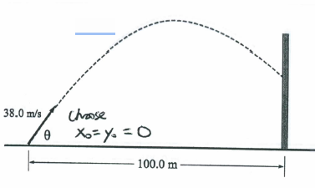

1. A satellite goes around the Earth in a circular orbit at constant speed at a distance of 2 x 104 km form the Earth’s center. The magnitude of the satellite’s acceleration is 1m/s2 . (a) What is the speed of the satellite? (b) How long does it take the satellite to make one revolution?[ Answer: 4.47 x 107 m/s , 2.81 x 104 sec]
2. An ion’s position vector is initially

,

and 10 s later it is

,

all in meters. In unit vector notation, what is its during the 10 s?

1. A ball is shot from the ground into air . At a hieght of 9.1 m , its velocity is 

with “i” horizontal and “j” upward. (a) To what maximum height does the ball rise? (b) What total horizontal distance does the ball travel? What are the (c) magnitude and (d) angle (below the horizontal) of the ball ‘s velocity just before it hits the ground?

